Open new profile
When do I create a new profile?
A new profile is created when you have searched student’s name, D.O.B. and contact details on AAS but there is no record so you need to create a new profile for this student.

- Click student on top of the main screen, it will take a few seconds to load the page.
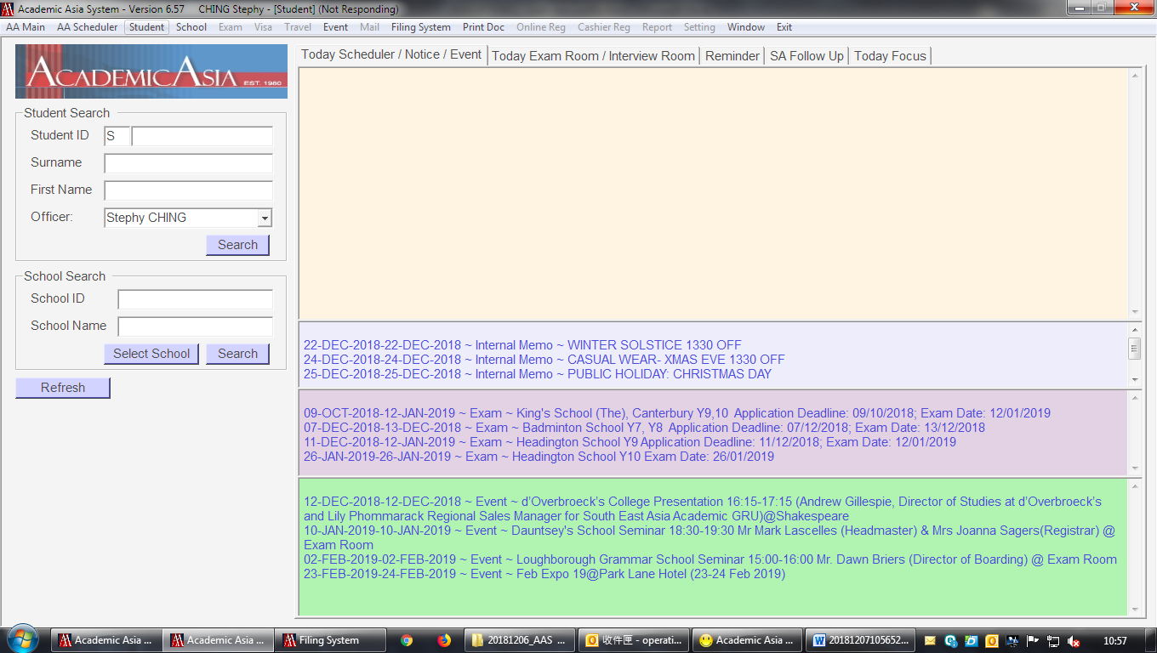
- The below box will open for you to search; open new file; or edit student profile, etc.
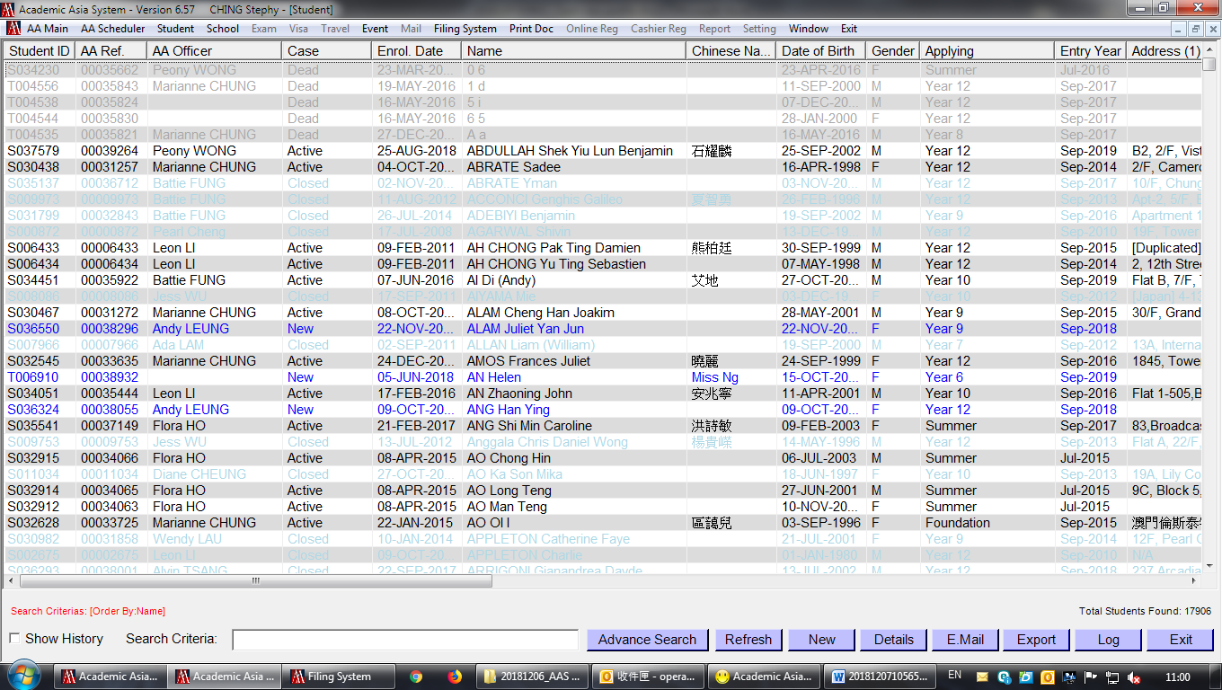
Click “NEW” to open new student profile

- The below box will pop out for you to input student details:
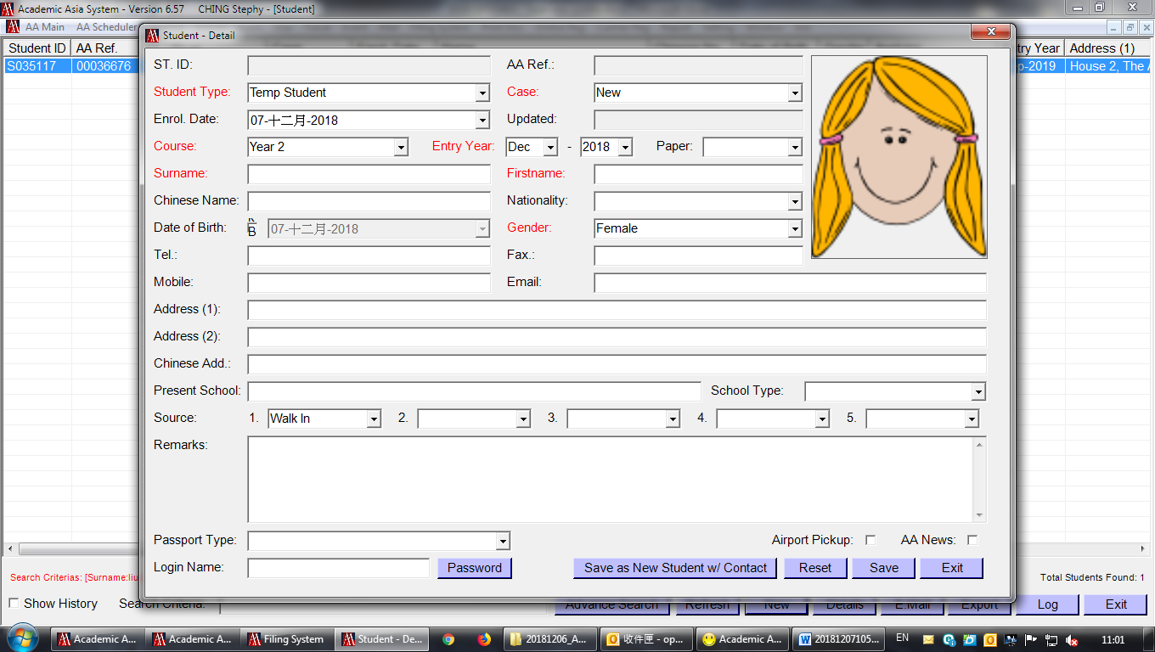
16
15
14
13
12
11
10
9
8
7
6
5
4
3
2
1
1. AA student – if consultants have seen the student already
Temp Student – when we make new booking, temp file will already be opened, we have to change from Temp to AA on the day when student is here for the appointment.
2. New – only use for Temp Student
Active – when student actually arrived for test or consultation
Closed – Dead case for AA student
3. Which course student apply for – make sure this is input correctly
4. Entry Year – make sure this is input correctly
5. Paper – which AA paper student sitting.
6. Surname – Must be in capital letter (e.g. CHAN)
7. Firstname - Chinese name or English name (e.g. Tai Man David), first letter must be capital
8. Chinese Name - try to input if possible
9. Nationality – the drop down button will have option for us to choose, key in any new type of nationality and the list will increase next time.
10. Date of Birth – tick the box to change the DOB, must be input correctly
11. Gender – the picture on the right will change
12. Address - Full address can be fill in the box, no need to separate country or city to the next box.
13. Chinese Address: for student who live in CHINA
14. Present School - School name must be in full (e.g. Diocesan Boys' School not DBS)
15. School Type: LOCAL – for all local schools in HK,
INTERNATIOAL,
CHINA,
UK or any other country.
16. How do they know about us, friends or events or newspaper, etc

You must input all the RED item in-order to create a file, then “SAVE” when finish.

- Press “Advance Search” to search the student profile which you’ve just opened.
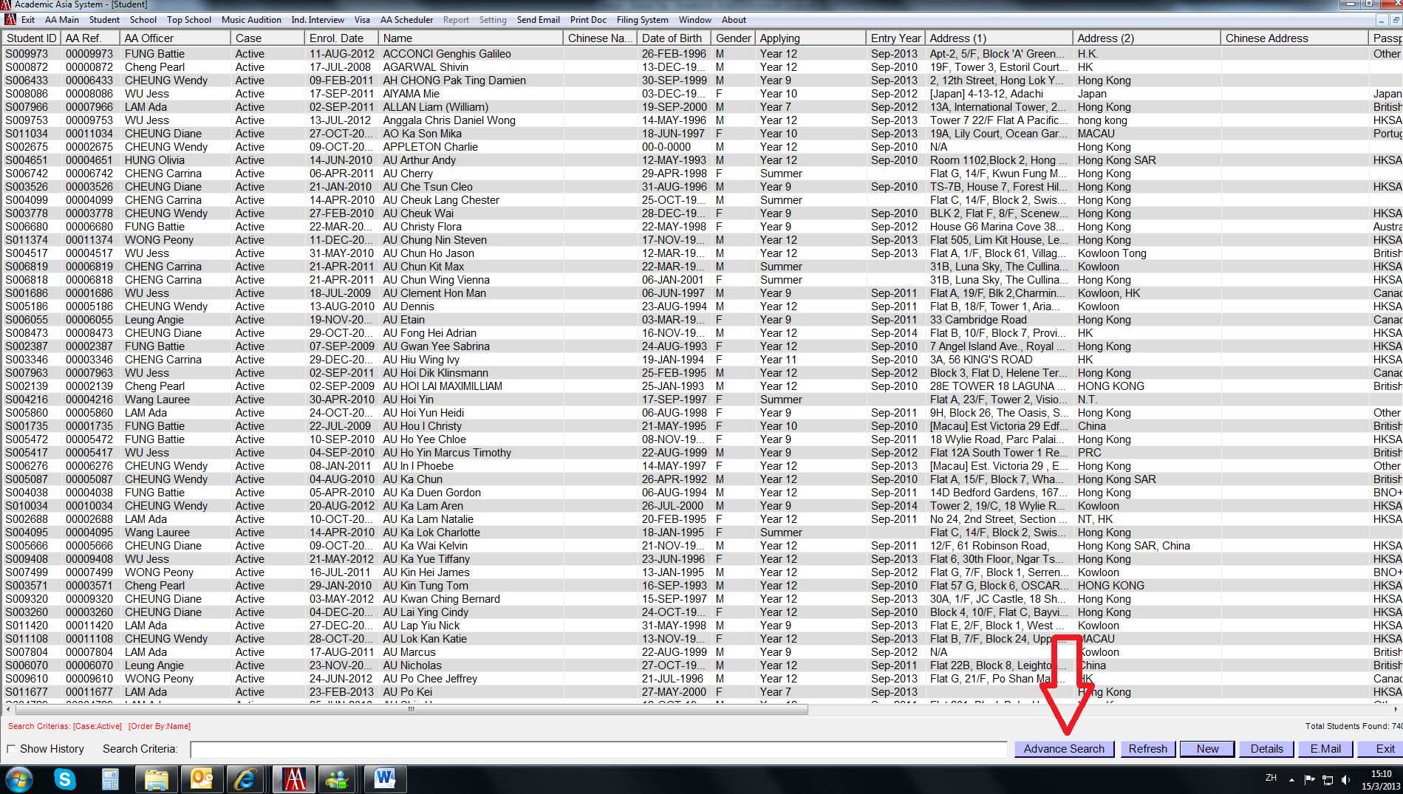
The below box will appear for you to select/key in any data to search for student profile.
- Press Clear first before you start – default ‘Case’ as Active, but some cases are New or Closed, etc., this action will allow you to search all students in sys.
- Try to input as much information as possible to minimize the result
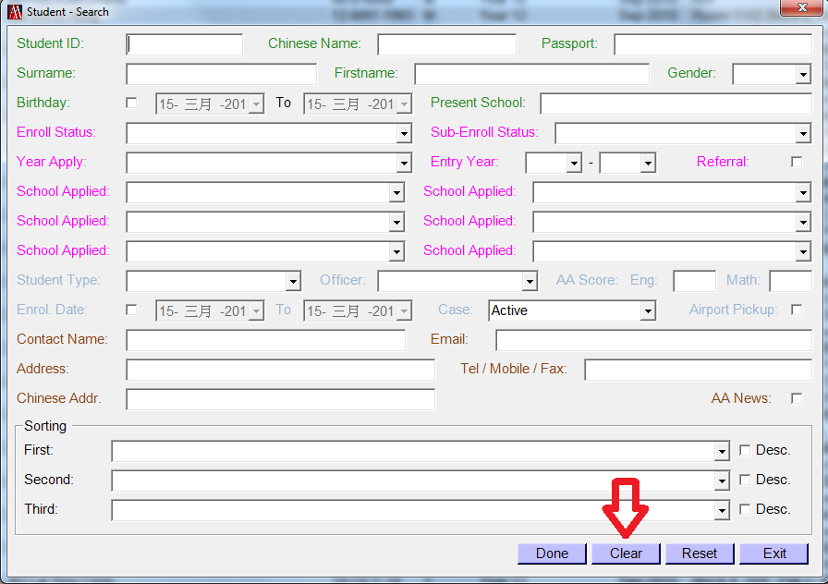

- Once found the student profile, you have to edit/add any additional information such as contact or supplementary info.
Click the icon button at the top of the page for which you are going to edit/add
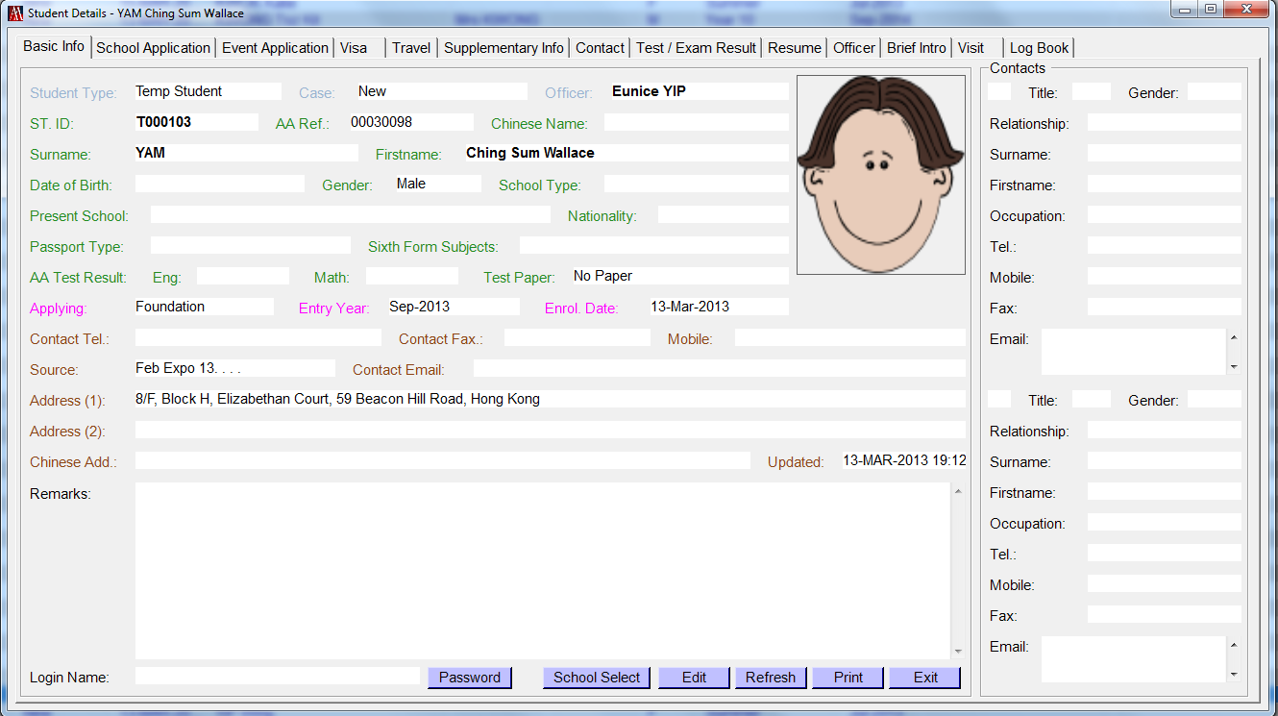
The below box will appear if you are adding contact, press new to add or double click the person to view details.
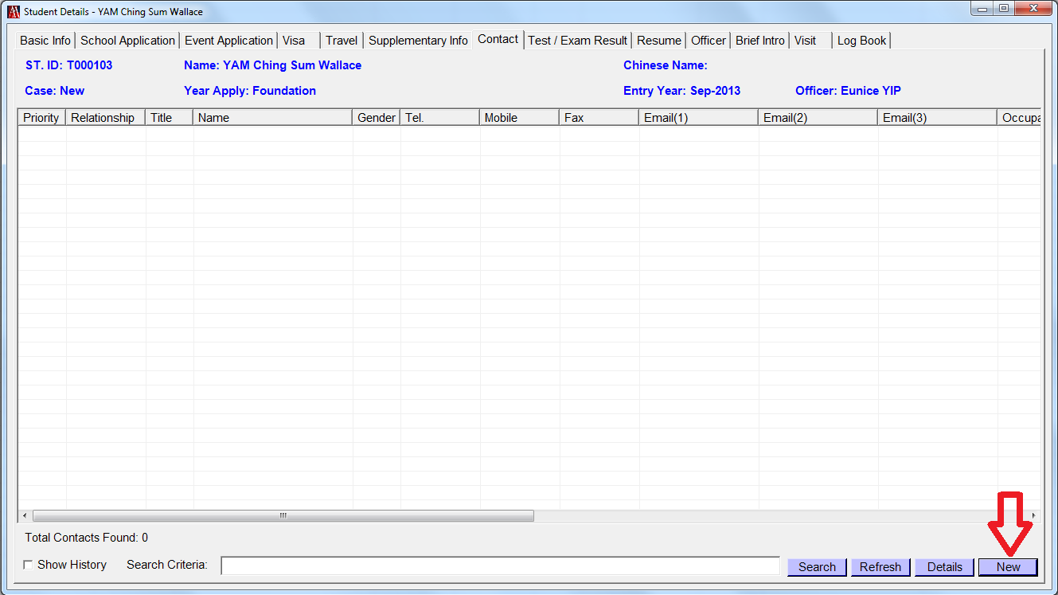

The below box will appear for you to add student contact, input as much information as possible. RED means you must input something in order to create contact. Then press “Save”
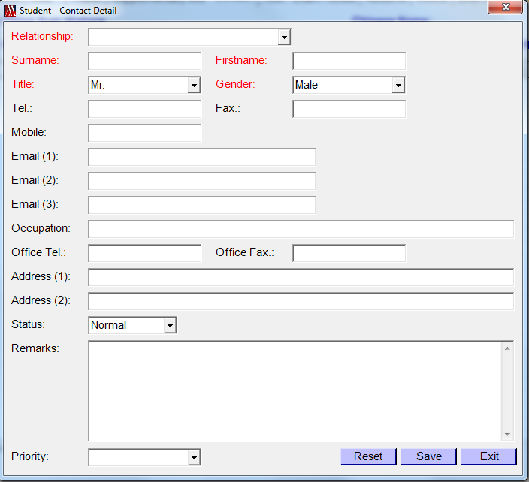

Same step for inputting supplementary info, AA officer (consultant-in-charge), and etc.

